CEBU INSTITUTE OF TECHNOLOGY
UNIVERSITY

COLLEGE OF COMPUTER STUDIES

Software Design Description
for
ReadRight

Change History Signature

Preface

Table of Contents

1. Introduction 6
1.1. Purpose 6
1.2. Scope 6
1.3. Definitions and Acronyms 6
1.4. References 6
2. Architectural Design 7
3. Detailed Design 8
Module 1 8
Module 2 9

Introduction

Purpose
This document is the Software Design Description (SDD) for ReadRight, a mobile-first Progressive Web Application (PWA) that provides Filipino Grade 4 learners with self-directed, Phil-IRI-aligned oral reading assessment and progress tracking. The SDD translates the finalized requirements established in the ReadRight Software Requirements Specification into a concrete architectural and detailed design, serving as the primary technical reference for implementation.
This document describes the overall system architecture, the decomposition of the system into modules, the design of each module's components (frontend, backend, and AI microservice), the object-oriented design expressed through class and sequence diagrams, and the data design through entity-relationship diagrams and database schema definitions.
The intended readers of this document are the ReadRight development team (Team Code: 2526-sem2-cs342-11), the course faculty and project panel at Cebu Institute of Technology – University, and any future evaluators of the system during pilot deployment. Developers should treat Sections 2 and 3 as the primary guides for implementation and integration. Panel reviewers should refer to Section 1 for scope and context, Section 2 for the architectural overview, and Section 3 for module-level design details.

Scope
ReadRight is a mobile-first Progressive Web Application (PWA) designed for Filipino Grade 4 learners to independently practice and assess their oral reading fluency against Phil-IRI standards, without requiring a teacher at any stage. The system serves a single primary user role: the individual Learner.
The system is organized around four general objectives:
- GO1 – Input Quality Verification: The system verifies that each recording meets minimum audio level, ambient noise, camera angle, and lighting quality thresholds before enabling recording submission to the AI pipeline.
- GO2 – Audio-Based Miscue Classification and Scoring: The system transcribes learner audio using WhisperX, performs forced alignment against the target passage, classifies all Phil-IRI miscue types, computes Words Per Minute (WPM) and word recognition percentage, and assigns a reading level classification (Frustration, Instructional, or Independent).
- GO3 – Video-Based Behavioral Analysis: The system detects all five Phil-IRI qualitative reading behaviors (finger-pointing, loss-of-place eye movements, monotone reading, word-by-word reading, and inaudible reading) and outputs a binary flag for each as part of the completed session record.
- GO4 – Session Results Display and Personal Progress Dashboard: The system presents a complete session results summary to the learner after each session and provides a personal progress dashboard displaying reading level trend, WPM progression, miscue breakdown, and behavioral history across al­l completed sessions.
ReadRight is built on a three-tier hybrid architecture: a React.js frontend styled with TailwindCSS communicates directly with Supabase for authentication and all persistent data storage, and calls a dedicated FastAPI (Python) AI microservice for recording submission and assessment result retrieval. The system is delivered as a cloud-hosted PWA installable from the browser, with no native mobile application and no offline functionality.

The following are explicitly outside the scope of this SDD and the ReadRight system:
- Reading comprehension evaluation (requires teacher-administered questioning).
- Grade levels other than Grade 4.
- Teacher-facing scheduling, intervention delivery, or DepEd documentation submission.
- Learner-selected passages (passage assignment is always random).
- Offline operation.
- Native mobile application distribution through an app store.
Pilot deployment is scoped to one private elementary school in Cebu City during Academic Year 2026–2027, First Semester.

Definitions and Acronyms
The following terms, acronyms, and abbreviations are used throughout this document and must be interpreted as defined below.
Term / Acronym | Definition
Phil-IRI | Philippine Informal Reading Inventory. The Department of Education's official standardized oral reading assessment instrument, administered under ECARP to classify learners into Frustration, Instructional, or Independent reading levels based on word recognition percentage, words per minute, and comprehension performance.
ECARP | Every Child a Reader Program. The DepEd mandate under which Phil-IRI is administered in Philippine public and private elementary schools.
DepEd | Department of Education. The Philippine government agency that sets national curriculum standards, including the Phil-IRI assessment framework.
PWA | Progressive Web Application. A web application delivered through the browser that can be installed on a device's home screen without requiring distribution through an app store. ReadRight is implemented as a PWA using standard web technologies.
ASR | Automatic Speech Recognition. The AI-based technology used to transcribe learner audio into text as the first step of the GO2 audio pipeline. Implemented in ReadRight using WhisperX.
WPM | Words Per Minute. The oral reading speed metric computed from forced alignment output during the GO2 pipeline.
Miscue | Any deviation from the target passage text during oral reading. The Phil-IRI miscue taxonomy defines seven types: Correct, Mispronunciation, Substitution, Omission, Insertion, Repetition, and Refusal to Pronounce.
Word Recognition % | The percentage of passage words read correctly. The primary numerical input to Phil-IRI reading level classification.
Reading Level | The three Phil-IRI classifications assigned based on word recognition percentage: Frustration, Instructional, and Independent.
Forced Alignment | Word-level matching of the ASR transcript to the target passage text with timestamps, enabling per-word miscue classification in the GO2 pipeline.
Passage Bank | The fixed set of Grade 4 Phil-IRI standard passages from which sessions are randomly assigned to the learner.
Qualitative Behaviors | The five Phil-IRI behavioral indicators detected by the GO3 video analysis pipeline: finger-pointing, loss-of-place eye movements, monotone reading, word-by-word reading, and inaudible reading.
API | Application Programming Interface. The communication interface between the React.js frontend and the backend services (Supabase and the FastAPI AI microservice).
REST | Representational State Transfer. The architectural style used for ReadRight's backend API, implemented through Supabase's auto-generated PostgREST interface.
CV | Computer Vision. The image processing technique used to detect physical reading behaviors from the video track in the GO3 pipeline, implemented using MediaPipe.
Supabase | An open-source backend-as-a-service platform built on PostgreSQL. Used in ReadRight for learner authentication, managed database storage, and auto-generated REST API access for session and progress data.
PostgreSQL | The relational database engine underlying Supabase. All session records, learner accounts, assessment results, and progress history are stored in PostgreSQL managed by Supabase.
FastAPI | A Python-based asynchronous web framework used to implement the ReadRight AI microservice. Receives MP4 recordings from the frontend and returns structured assessment result JSON after executing the GO2 and GO3 pipelines.
WhisperX | The ASR model used in the GO2 audio pipeline for transcription and forced alignment of learner recordings.
MediaPipe | The computer vision library used in the GO3 video pipeline for detecting finger-pointing and loss-of-place eye movements.
librosa | A Python audio analysis library used in the GO3 pipeline for onset detection to identify word-by-word reading patterns and RMS energy computation for inaudible reading detection.
Parselmouth | A Python library wrapping Praat for prosody analysis. Used in the GO3 pipeline to extract fundamental frequency (F0) contour for monotone reading detection.
getUserMedia | A browser API used to access the device's camera and microphone for recording. Required on both mobile and desktop browsers for all ReadRight recording sessions.
MediaRecorder | A browser API used to capture audio and video streams from getUserMedia into a submittable MP4 file for AI pipeline processing.
Service Worker | A browser script that enables PWA features such as home screen installation. Does not provide offline functionality in ReadRight.
RLS | Row-Level Security. The PostgreSQL and Supabase security mechanism used to restrict each learner's database access to their own records only, enforced through JWT user ID claims.
JWT | JSON Web Token. The authentication token issued by Supabase Auth on learner login. Attached to all subsequent API requests as a Bearer token and used by RLS policies to enforce per-learner data access.
MP4 | The video file format is used to store and transmit learner recordings from the browser to the FastAPI AI microservices.
FFmpeg | A multimedia processing library used within the FastAPI microservice to extract the WAV audio track from the submitted MP4 recording for use in both the GO2 and GO3 pipelines.
React.js | The JavaScript library used to build ReadRight's learner-facing frontend. Communicates with Supabase for authentication and data, and with the FastAPI microservice for AI processing.
TailwindCSS | The utility-first CSS framework used for styling the ReadRight frontend. Ensures mobile-first, responsive layout across device types.

References
The following documents were used as source material for this SDD:
ReadRight Software Requirements Specification (SRS), Version 1.0, 05 May 2026. Team Code: 2526-sem2-cs342-11. Primary source for all objectives, scope boundaries, system workflow, module decomposition, and technical constraints described in this document.
ReadRight Software Proposal Writing, Version 2. Team Code: 2526-sem2-cs342-11. Original source for system concept, general objectives, research questions, and development methodology.
Philippine Department of Education. Phil-IRI (Philippine Informal Reading Inventory) Administration and Scoring Manual. DepEd, Manila.
Esteban, A. J., Calang, K., & Pagador, P. M. (2024). A review of practices and digital technology integration in reading instruction and suggestions for the Philippines. https://doi.org/10.11591/ijere.v13i6.29856
Gao, L., Tejedor-Garcia, C., Strik, H., & Cucchiarini, C. (2024). Reading miscue detection in primary school through automatic speech recognition. Proceedings of Interspeech 2024. https://doi.org/10.21437/Interspeech.2024-1180
Van der Velde, M., Harmsen, W., & Veldkamp, B. (2025). Speech enabled reading fluency assessment: A validation study. https://doi.org/10.1007/s40593-025-00480-y

Architectural Design

2.1 High-Level System Structure
ReadRight is built on a three-tier hybrid architecture designed to separate learner-facing interaction, AI computation, and persistent data storage into discrete, independently deployable components.
The first tier is the client layer: a React.js frontend styled with TailwindCSS, delivered as a mobile-first Progressive Web Application (PWA) served over HTTPS. The PWA is installable on the learner’s device home screen via a Service Worker and Web App Manifest. The Service Worker is used exclusively for installation support and does not provide offline caching, background sync, or push notifications. An active network connection is required for all recording submission, AI processing, and result retrieval operations. All learner-facing functionality, such as passage display, GO1 quality check feedback, recording controls, session results presentation, and the personal progress dashboard, is implemented in the React.js frontend.
The second tier is the FastAPI AI microservice: a dedicated, cloud-hosted Python service that handles all AI audio and video processing exclusively. The frontend submits the learner’s MP4 recording to the FastAPI /analyze endpoint via a long-lived synchronous HTTP POST. The microservice executes the GO2 audio pipeline (WhisperX ASR, forced alignment, Phil-IRI miscue classification, WPM computation, word recognition percentage, and reading level classification) and the GO3 video pipeline (MediaPipe computer vision, librosa and Parselmouth prosody analysis, five Phil-IRI behavioral flags) in parallel. Upon pipeline completion, the microservice returns a structured JSON result to the frontend and writes the session record to Supabase. Recording files are transient and deleted from the microservice after the write is confirmed.
The third tier is the auth and data layer, implemented entirely through Supabase. Supabase provides learner authentication via Supabase Auth (JWT-based), a managed PostgreSQL database, and an auto-generated PostgREST REST API. The React.js frontend communicates with Supabase directly via the official Supabase JavaScript client SDK (@supabase/supabase-js) for all authentication, session storage, and progress data retrieval. Row-Level Security (RLS) policies on the Supabase database use the JWT’s user ID claim to restrict each learner’s access to their own records. The FastAPI microservice also writes session records directly to Supabase upon pipeline completion.

2.2 Technology Stack
Layer | Technology
Frontend | React.js + TailwindCSS
Auth + Database | Supabase (managed PostgreSQL + Auth + PostgREST REST API)
AI Microservice | FastAPI (Python, async)
AI Libraries (GO2) | WhisperX, forced alignment engine, rule-based miscue classifier
AI Libraries (GO3) | MediaPipe (CV), librosa, Parselmouth
Browser APIs (client-side, GO1 only) | getUserMedia, MediaRecorder, Web Audio API, Canvas API, MediaPipe WASM
Deployment | Cloud-hosted PWA over HTTPS

2.3 System Block Diagram

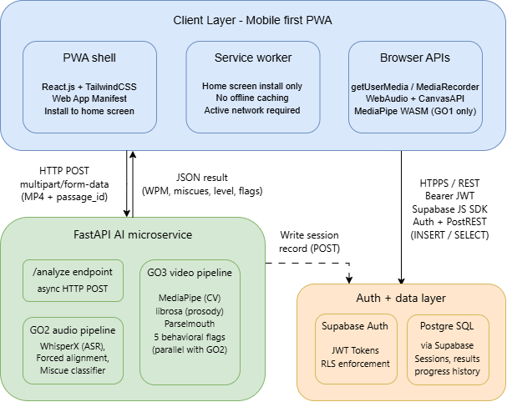

2.4 Architecture Viewpoints

2.4.1 Context View: User ↔ System
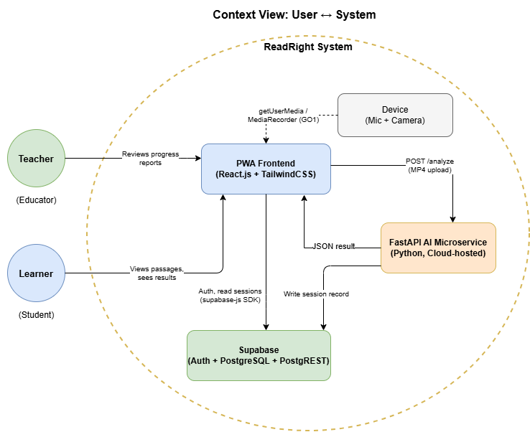

2.4.2 Composition View: Modules
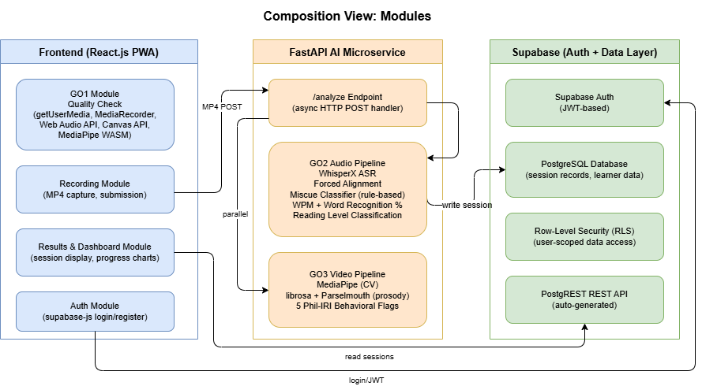

2.4.3 Logical View: Classes
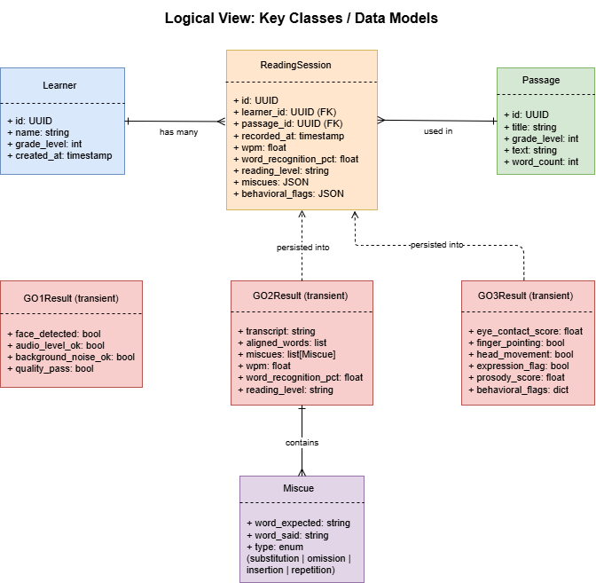

2.4.4 Dependency View: API Calls
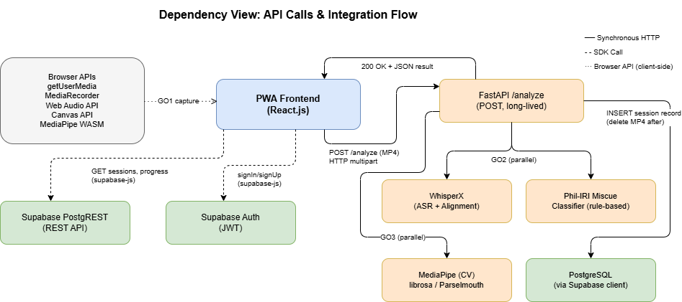

Detailed Design
This section describes the detailed design of all four ReadRight modules, corresponding to GO1 through GO4 as specified in the SRS (Version 1.0). Each transaction is documented with its front-end components, back-end components, object-oriented design diagrams (class and sequence), and data design (table schema relevant to that transaction).

Object-Oriented Components
The following class diagram covers the full GO1 module. The QualityCheckManager coordinates all four checker classes and exposes the combined gate state to the recording interface.
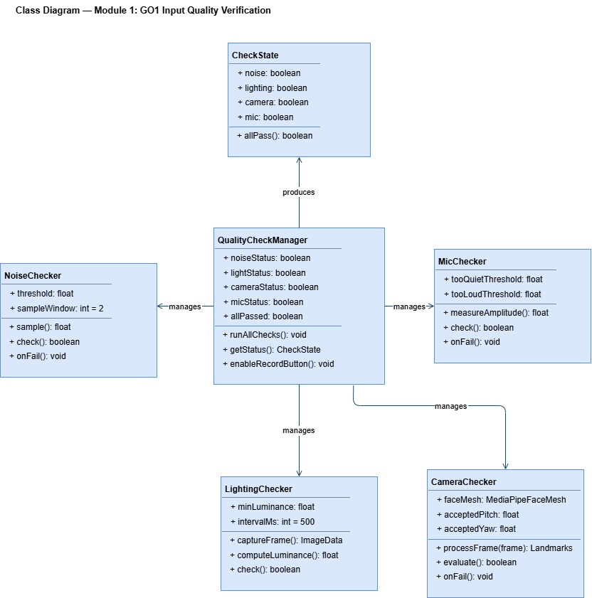

Module 1 - G01: Input Quality Verification
Module 1 implements the four parallel real-time quality checks that must all pass before the learner is allowed to initiate a recording. All checks run simultaneously in the browser as soon as the session screen is opened. The module is implemented entirely in the React.js frontend using browser APIs (Web Audio API, getUserMedia, Canvas API, MediaPipe WASM).

1.1 Ambient Noise Check

Front-End Component
Property | Value
Component Name | NoiseChecker
Description and Purpose | Attaches a Web Audio API AnalyserNode to the active getUserMedia audio stream. Samples the ambient noise floor over a 2-second window before any speech. If the measured noise floor is below the defined threshold the check is marked PASS; otherwise FAIL. Re-samples every 2 seconds automatically and updates the indicator without learner action.
Component Type / Format | React custom hook (useNoiseCheck) — returns { noiseStatus: boolean, message: string }. Renders a PASS/FAIL indicator chip in the SessionScreen component.

Back-End Component
No back-end component. This check runs entirely in the browser using the Web Audio API AnalyserNode. No data is sent to the server.

Sequence Diagram

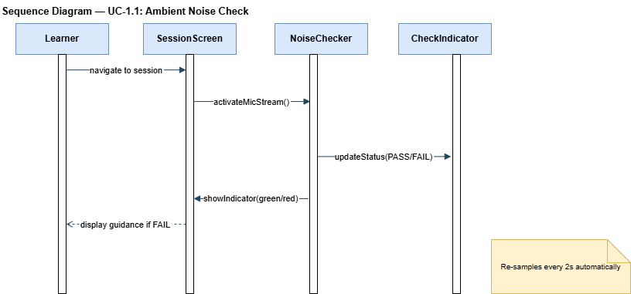

Data Design
No persistent data is written for this transaction. The noise check result is held in React component state (CheckState) and contributes to the in-memory GO1 gate evaluation only. It is not stored in Supabase.

1.2 Ambient Lighting Check

Front-End Component
Property | Value
Component Name | LightingChecker
Description and Purpose | Draws live camera frames onto an off-screen HTML Canvas element every 500ms using the getUserMedia video stream. Reads per-pixel luminance values from the canvas ImageData and computes the average luminance. If the average meets or exceeds the defined minimum threshold the check passes. Re-evaluates every 500ms automatically.
Component Type / Format | React custom hook (useLightingCheck) — returns { lightStatus: boolean, message: string }. Renders a PASS/FAIL indicator chip in the SessionScreen component. Uses a hidden <canvas> element for luminance sampling.

Back-End Component
No back-end component. Luminance computation is performed client-side via the Canvas 2D API. No data is sent to the server.

Sequence Diagram
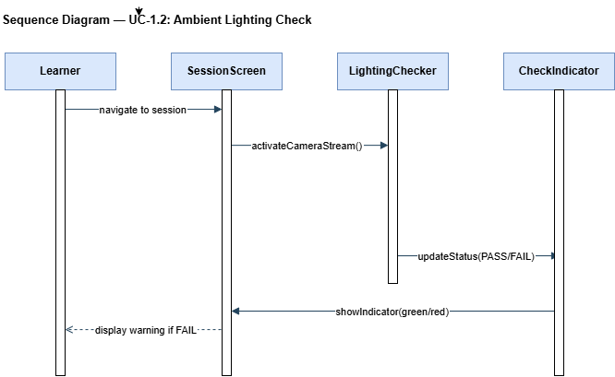

Data Design
No persistent data. The lighting check result is held in React state and contributes to the in-memory GO1 gate evaluation only.

1.3 Camera Angle Check

Front-End Component
Property | Value
Component Name | CameraChecker
Description and Purpose | Passes live camera frames to the in-browser MediaPipe Face Mesh WASM module. Evaluates the returned facial landmark coordinates to determine whether the detected face is within the acceptable center region of the frame and within the acceptable pitch/yaw angle range. Provides directional feedback if the face is out of position. Re-evaluates per frame.
Component Type / Format | React custom hook (useCameraCheck) — returns { cameraStatus: boolean, message: string }. Uses the @mediapipe/face_mesh WASM package loaded in the browser. Renders a PASS/FAIL indicator chip and live camera preview in the SessionScreen component.

Back-End Component
No back-end component. MediaPipe Face Mesh runs entirely in the browser as a WASM module. No camera frames are transmitted to the server during the GO1 phase.

Sequence Diagram
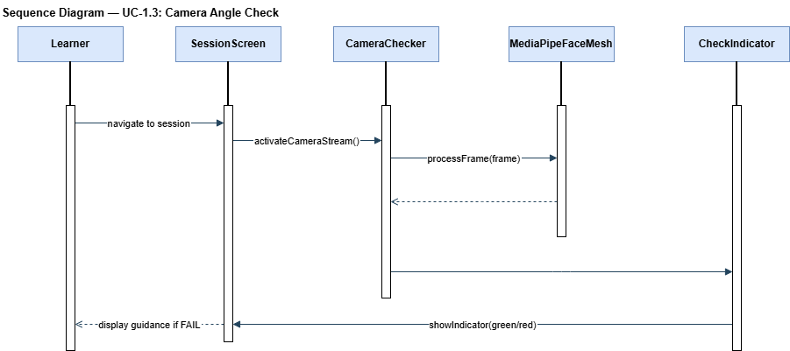

Data Design
No persistent data. The camera angle check result is held in React state and contributes to the in-memory GO1 gate evaluation only.

1.4 Microphone Volume Check

Front-End Component
Property | Value
Component Name | MicChecker
Description and Purpose | Attaches a Web Audio API AnalyserNode to the active getUserMedia audio stream and continuously measures peak input amplitude. If the amplitude is above the too-quiet threshold and below the too-loud threshold the check passes. Displays a live animated volume level bar to the learner. Updates in real-time without learner-triggered re-evaluation.
Component Type / Format | React custom hook (useMicCheck) — returns { micStatus: boolean, amplitude: number, message: string }. Renders a live volume bar and PASS/FAIL indicator chip in the SessionScreen component.

Back-End Component
No back-end component. Amplitude measurement is performed entirely client-side using the Web Audio API AnalyserNode. No audio data is transmitted during the check.

Sequence Diagram
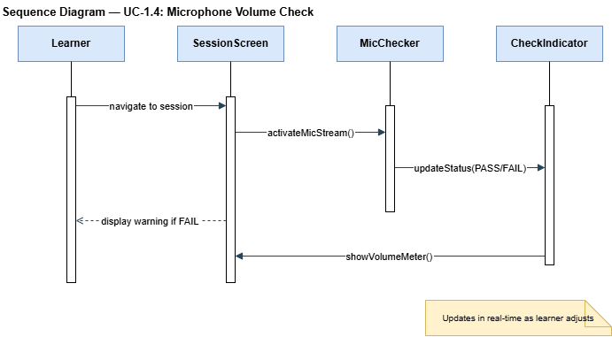

Data Design
No persistent data. The microphone volume check result is held in React state and contributes to the in-memory GO1 gate evaluation only.

1.5 Recording Interface Gate

Front-End Component
Property | Value
Component Name | RecordingGate
Description and Purpose | Continuously evaluates the real-time combined state of all four GO1 checker hooks. Enables the Record button only when all four checks simultaneously return PASS. On Record click, initialises MediaRecorder on the combined getUserMedia audio+video stream and begins capturing the session. On Stop, finalises the MP4 blob, attaches the passage_id, and submits the recording to the FastAPI microservice via HTTP POST. Displays a processing loading screen for the duration of the pipeline.
Component Type / Format | React component (RecordingGate) — consumes the four check hook states via a useQualityGate aggregator hook. Renders the Record/Stop button, passage text display, and post-submission processing screen. Uses the browser MediaRecorder API with MIME type video/mp4.

Back-End Component
Property | Value
Component Name | FastAPI /analyze Endpoint (entry point)
Description and Purpose | Receives the multipart/form-data POST request containing the MP4 file and passage_id. This transaction covers only the submission step; the AI pipeline processing is handled in Module 2 (GO2) and Module 3 (GO3).
Component Type / Format | FastAPI POST endpoint — /analyze. Accepts multipart/form-data: { file: MP4 binary, passage_id: string }. Returns 200 with AssessmentResultJSON on success or 500 with error code on pipeline failure.

Sequence Diagram

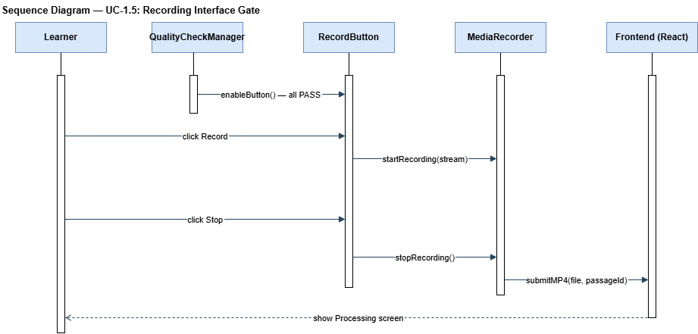

Data Design
No persistent data is written for this transaction. The MP4 recording is a transient in-memory blob on the frontend and a transient file on the FastAPI server during processing. It is deleted from the server after the pipeline completes. No recording files are stored in Supabase.

Module 2 — GO2: Audio-Based Miscue Classification and Scoring
Module 2 implements the complete GO2 audio pipeline inside the FastAPI AI microservice. It is triggered when the frontend submits a valid MP4 recording to POST /analyze. The four transactions in this module run sequentially within the same microservice request: audio extraction, ASR and forced alignment, miscue classification, and scoring with reading level classification. The final consolidated GO2 output is held until the parallel GO3 pipeline (Module 3) completes, after which the full assessment result JSON is returned to the frontend.

Object-Oriented Components
The following class diagram covers the full GO2 audio pipeline. All classes reside within the FastAPI microservice process.
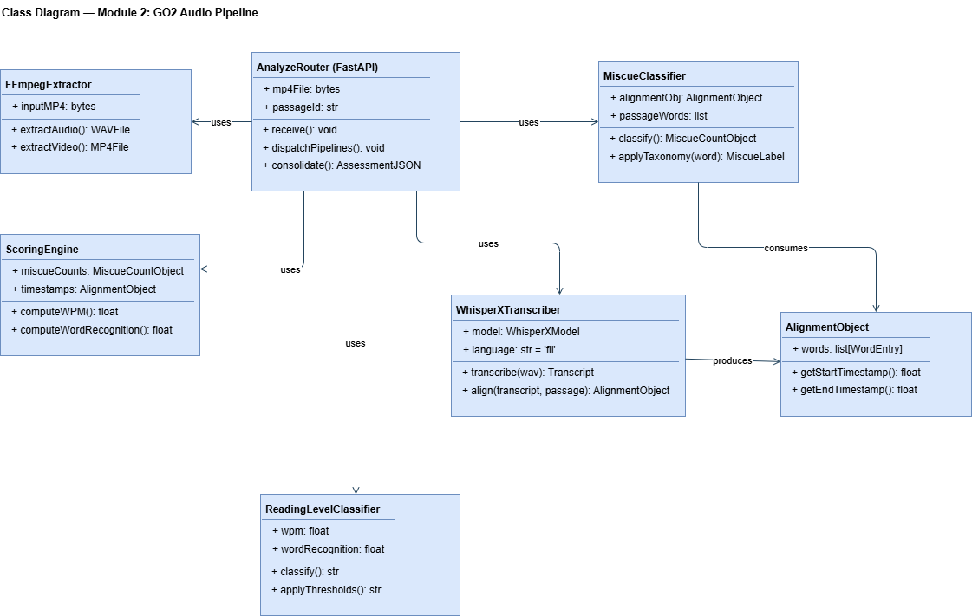

2.1 Audio Transcription and Forced Alignment

Front-End Component
Property | Value
Component Name | ProcessingScreen
Description and Purpose | Displayed immediately after the learner submits the recording. Shows an animated multi-step progress indicator (Uploading → Transcribing → Scoring → Done) and a "Do not close this screen" notice. Holds the HTTP connection open while awaiting the FastAPI response. Handles timeout after 120 seconds with a retry prompt.
Component Type / Format | React component (ProcessingScreen) — stateless display component. Driven by the submission state machine in RecordingGate. Renders a step-progress UI aligned with the SRS wireframe for the Processing screen.

Back-End Components
Property | Value
Component Name | FFmpegExtractor
Description and Purpose | Invokes FFmpeg as a subprocess to extract the audio-only WAV track from the submitted MP4. The WAV file is written to a temporary path on the microservice server. The same WAV file is shared with the GO3 prosody pipeline (UC-3.2) with no duplicate extraction.
Component Type / Format | Python class using subprocess.run() to call FFmpeg. Output: WAV file at a temp path. Called synchronously before the pipeline fans out.

Property | Value
Component Name | WhisperXTranscriber
Description and Purpose | Loads the WhisperX ASR model and transcribes the WAV audio. Then performs word-level forced alignment between the transcript and the target passage text retrieved from the passage bank using the passage_id. Produces a word-level AlignmentObject mapping each passage word to its transcribed form with start and end timestamps.
Component Type / Format | Python class wrapping the whisperx library. Methods: transcribe(wav_path) → Transcript, align(transcript, passage_text) → AlignmentObject. If transcription fails, raises TRANSCRIPTION_FAILED; if alignment is incomplete, missing words are treated as omissions.

Sequence Diagram
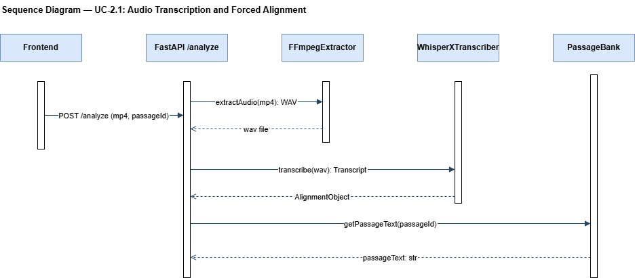

Data Design
No persistent data is written by this transaction. The AlignmentObject is an in-memory Python dict held in the microservice process and passed directly to UC-2.2. The WAV file is a temporary disk file deleted after pipeline completion.

2.2 Phil-IRI Miscue Classification

Front-End Component
No front-end component for this transaction. The miscue classifier is a fully automated server-side process. The frontend remains on the ProcessingScreen (see UC-2.1) throughout this stage.

Back-End Component
Property | Value
Component Name | MiscueClassifier
Description and Purpose | Receives the word-level AlignmentObject from UC-2.1. Applies the Phil-IRI miscue taxonomy rule-by-rule to each passage word: Correct, Mispronunciation, Substitution, Omission, Insertion, Repetition, Refusal to Pronounce. On ambiguous classification, defaults to the more conservative label (Mispronunciation over Substitution). Produces a MiscueCountObject with seven integer fields.
Component Type / Format | Python class with method classify(alignment_obj) → MiscueCountObject. Rule-based logic using string comparison and phonetic similarity. Output: Python dict { correct: int, mispronunciation: int, substitution: int, omission: int, insertion: int, repetition: int, refusal_to_pronounce: int }.

Sequence Diagram
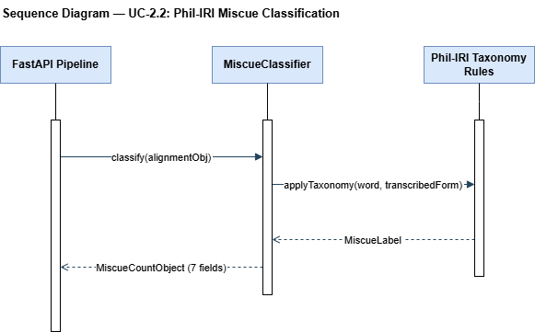

Data Design
No persistent data is written by this transaction. The MiscueCountObject is in-memory and passed directly to UC-2.3.

2.3 WPM and Word Recognition Percentage Computation

Front-End Component
No front-end component. Computation is fully automated in the FastAPI microservice.

Back-End Component
Property | Value
Component Name | ScoringEngine
Description and Purpose | Receives the AlignmentObject (timestamps) from UC-2.1 and the MiscueCountObject from UC-2.2. Computes: (1) Total reading time in minutes from the start and end timestamps of the first and last aligned word. (2) WPM = total passage word count / reading time in minutes. (3) Correctly read words = total passage words minus omissions, substitutions, mispronunciations, and refusals to pronounce. Insertions and repetitions are not deducted per Phil-IRI scoring rules. (4) Word recognition % = (correctly read words / total passage words) × 100.
Component Type / Format | Python class with methods computeWPM(alignment_obj) → float and computeWordRecognition(miscue_counts, total_words) → float. If timestamps yield zero reading time, raises SCORING_FAILED. Outputs wpm (float) and word_recognition_pct (float) passed to UC-2.4.

Sequence Diagram

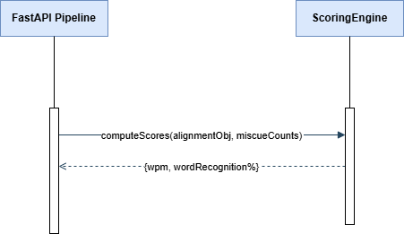

Data Design
No persistent data. WPM and word recognition percentage are in-memory float values passed to UC-2.4.

2.4 Phil-IRI Reading Level Classification

Front-End Component
No front-end component. Classification is fully automated. The frontend remains on the ProcessingScreen.

Back-End Component
Property | Value
Component Name | ReadingLevelClassifier
Description and Purpose | Applies the Phil-IRI Grade 4 scoring thresholds to the word recognition percentage: Independent ≥ 97%, Instructional 91–96%, Frustration ≤ 90%. Applies Phil-IRI WPM benchmarks as a secondary confirmation signal. On exact boundary values, applies the lower classification (conservative). Consolidates the full GO2 output — WPM, word recognition %, reading level, and miscue count object — into the assessment result JSON. Holds the GO2 result pending completion of the parallel GO3 pipeline before the combined JSON is returned to the frontend.
Component Type / Format | Python class with method classify(wpm, word_recognition_pct) → str. Output: reading_level string joined with GO2 scores into a partial AssessmentResultJSON dict. This dict is merged with GO3 behavioral flags (from Module 3) by the ResultConsolidator before the response is returned.

Sequence Diagram
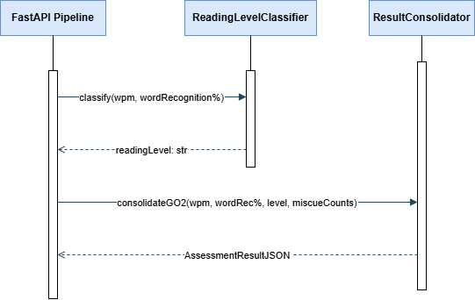

Data Design
The table below describes the fields produced by the GO2 pipeline that are written to the Supabase sessions table after the complete JSON is returned to the frontend. The full sessions table schema (including GO3 behavioral flag columns) is shown in UC-4.2.
Field | Description / Source
wpm | float — WPM computed by ScoringEngine (UC-2.3)
word_recognition_pct | float — word recognition % computed by ScoringEngine (UC-2.3)
reading_level | varchar(20) — classification string from ReadingLevelClassifier (UC-2.4). Values: Frustration | Instructional | Independent
correct | integer — count from MiscueClassifier (UC-2.2)
mispronunciation | integer — count from MiscueClassifier (UC-2.2)
substitution | integer — count from MiscueClassifier (UC-2.2)
omission | integer — count from MiscueClassifier (UC-2.2)
insertion | integer — count from MiscueClassifier (UC-2.2)
repetition | integer — count from MiscueClassifier (UC-2.2)
refusal_to_pronounce | integer — count from MiscueClassifier (UC-2.2)

Module 3 - GO3: Video-Based Behavioural Analysis
Module 3 implements the GO3 behavioral analysis pipeline inside the FastAPI AI microservice. It runs in parallel with the GO2 pipeline (Module 2) on the same server, sharing the WAV audio file extracted by FFmpegExtractor. UC-3.1 processes the video track using MediaPipe for computer vision detections; UC-3.2 processes the audio track using librosa and Parselmouth for prosody and amplitude detections. After both transactions complete, the five binary behavioral flags are merged with the GO2 result by the ResultConsolidator and the complete AssessmentResultJSON is returned to the frontend.

Object-Oriented Components
The following class diagram covers the full GO3 module. All classes reside within the FastAPI microservice process.

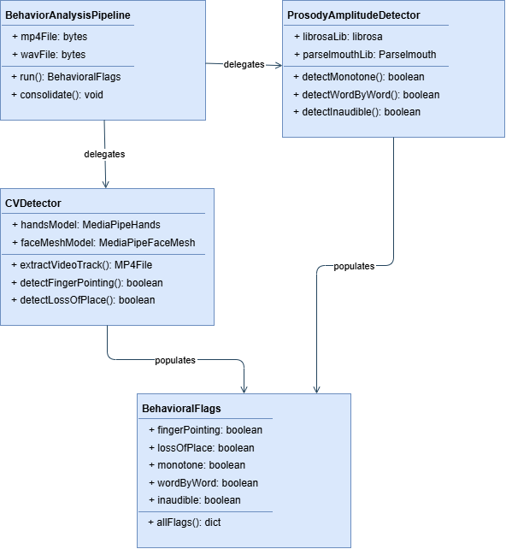

3.1 Computer Vision Behavioral Detection

Front-End Component
No front-end component. This transaction is fully automated within the FastAPI microservice. The frontend remains on the ProcessingScreen.

Back-End Components
Property | Value
Component Name | CVDetector — Finger-Pointing Detection
Description and Purpose | Uses MediaPipe Hands to process the video track frame-by-frame. Checks each frame for the presence of an extended index finger positioned near or below the text area of the frame. If detected in any frame, sets finger_pointing = True.
Component Type / Format | Python class method detectFingerPointing(video_path) → boolean. Uses the mediapipe library with Hands solution. If no hand is detected across all frames, flag defaults to False.

Property | Value
Component Name | CVDetector — Loss-of-Place Detection
Description and Purpose | Uses MediaPipe Face Mesh to track iris landmark positions frame-by-frame from the video track. Counts abrupt lateral or vertical gaze shifts whose magnitude exceeds the defined threshold. If the count exceeds the defined frequency threshold, sets loss_of_place = True.
Component Type / Format | Python class method detectLossOfPlace(video_path) → boolean. Uses the mediapipe library with FaceMesh solution and iris landmark indices. If no face is detected across all frames, flag defaults to False.

Sequence Diagram

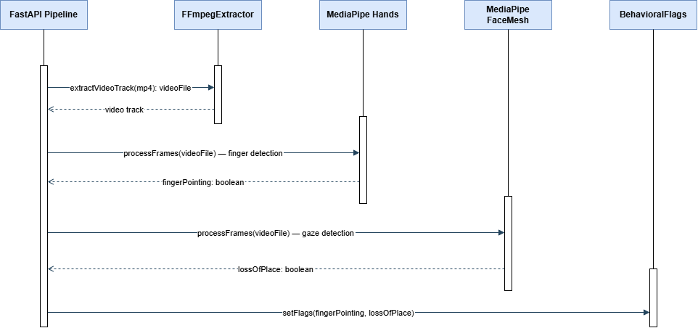

Data Design
No persistent data written by this transaction. The two CV binary flags (finger_pointing, loss_of_place) are held in-memory in a BehavioralFlags object and merged with GO3 prosody flags after UC-3.2 completes.

3.2 Prosody and Amplitude Behavioral Detection

Front-End Component
No front-end component. Fully automated within the FastAPI microservice.

Back-End Components
Property | Value
Component Name | ProsodyAmplitudeDetector — Monotone Reading Detection
Description and Purpose | Uses Parselmouth to extract the fundamental frequency (F0) contour of the learner's voice across the full WAV recording. Computes the standard deviation of the F0 contour. If the standard deviation falls below the defined pitch variation threshold, sets monotone_reading = True. If the recording is too short for reliable F0 extraction, defaults to False (conservative).
Component Type / Format | Python class method detectMonotone(wav_path) → boolean. Uses the parselmouth library (Praat wrapper). F0 extraction uses Parselmouth's Sound.to_pitch() method.

Property | Value
Component Name | ProsodyAmplitudeDetector — Word-by-Word Reading Detection
Description and Purpose | Uses librosa onset detection to identify inter-word silence boundaries in the WAV recording. Computes the mean inter-word pause duration. If the mean pause duration exceeds the defined threshold, sets word_by_word_reading = True.
Component Type / Format | Python class method detectWordByWord(wav_path) → boolean. Uses librosa.onset.onset_detect() and inter-onset interval analysis.

Property | Value
Component Name | ProsodyAmplitudeDetector — Inaudible Reading Detection
Description and Purpose | Uses librosa to compute the root-mean-square (RMS) energy of the full WAV audio signal. If the mean RMS energy falls below the defined amplitude threshold, sets inaudible_reading = True. If the recording is entirely silent, also sets inaudible_reading = True.
Component Type / Format | Python class method detectInaudible(wav_path) → boolean. Uses librosa.feature.rms().

Sequence Diagram

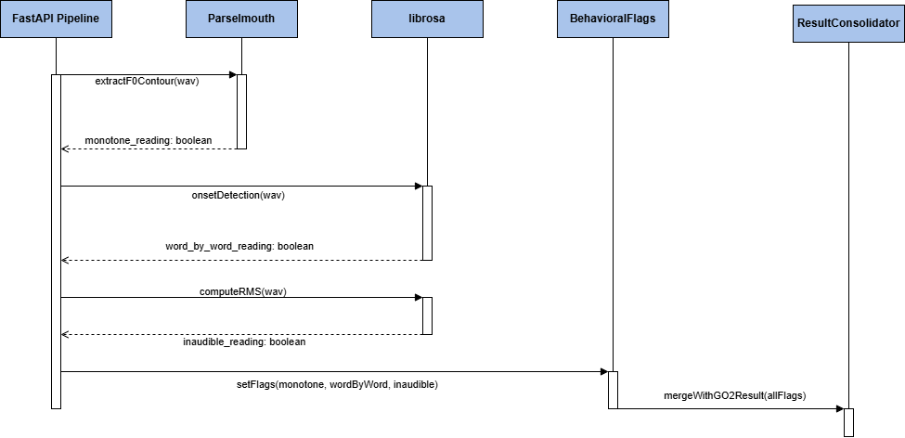

Data Design
The five GO3 binary flags are merged with the GO2 result by the ResultConsolidator after both pipelines complete. The merged output is the complete AssessmentResultJSON returned to the frontend and eventually written to the Supabase sessions table. See UC-4.2 for the full sessions table schema.
Field | Description / Source
finger_pointing | boolean — output of CVDetector.detectFingerPointing() (UC-3.1). True if index finger positioned near text in any frame.
loss_of_place | boolean — output of CVDetector.detectLossOfPlace() (UC-3.1). True if abrupt gaze shifts exceed frequency threshold.
monotone_reading | boolean — output of ProsodyAmplitudeDetector.detectMonotone() (UC-3.2). True if F0 std dev below pitch variation threshold.
word_by_word_reading | boolean — output of ProsodyAmplitudeDetector.detectWordByWord() (UC-3.2). True if mean inter-word pause exceeds threshold.
inaudible_reading | boolean — output of ProsodyAmplitudeDetector.detectInaudible() (UC-3.2). True if mean RMS energy below amplitude threshold.

Module 4 - GO4: Session Results Display and Personal Progress Dashboard
Module 4 covers the frontend and database operations that occur after the FastAPI microservice returns the complete AssessmentResultJSON. This module is implemented primarily in the React.js frontend with Supabase as the persistent storage layer. Four transactions handle results display, database write, and the two dashboard chart groups.

Object-Oriented Components
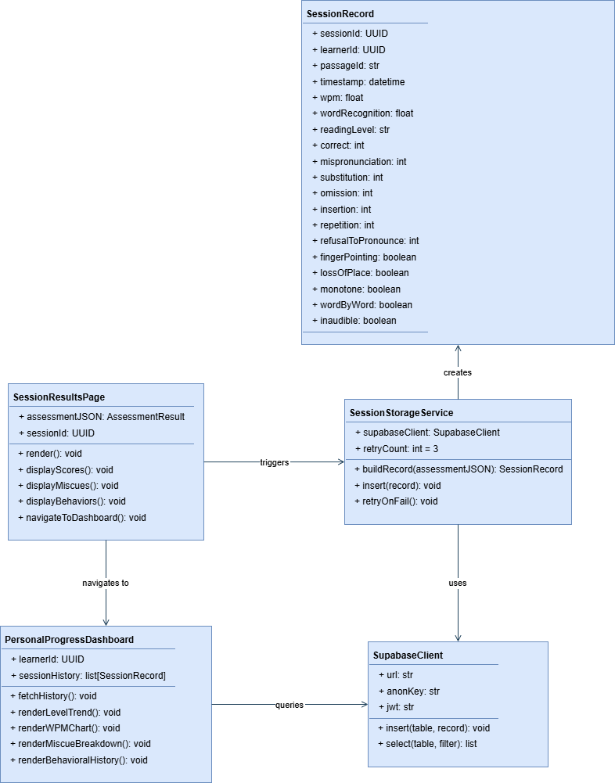

4.1 Session Results Display

Front-End Component
Property | Value
Component Name | SessionResultsPage
Description and Purpose | Receives the AssessmentResultJSON from the RecordingGate submission handler. Renders the full session results to the learner: (a) WPM value with plain-language label and Grade 4 benchmark for reference, (b) word recognition percentage with Phil-IRI range label, (c) reading level classification badge (Frustration / Instructional / Independent) with a plain-language explanation, (d) miscue type breakdown as a bar list (mispronunciation, substitution, omission, insertion, repetition, refusal to pronounce counts), (e) behavioral checklist showing each of the five Phil-IRI behavioral flags with a plain-language description. Includes a "Go to Dashboard" navigation button.
Component Type / Format | React page component (SessionResultsPage). Receives assessmentJSON as a prop or from React Router state. Renders statically from the received JSON — no additional API calls. Aligned to the SRS wireframe for the Session Results page.

Back-End Component
No additional back-end processing for this transaction. The FastAPI microservice has already returned the complete JSON before this component renders. The Supabase write is handled by UC-4.2 (SessionStorageService) which is triggered in parallel with rendering.

Sequence Diagram
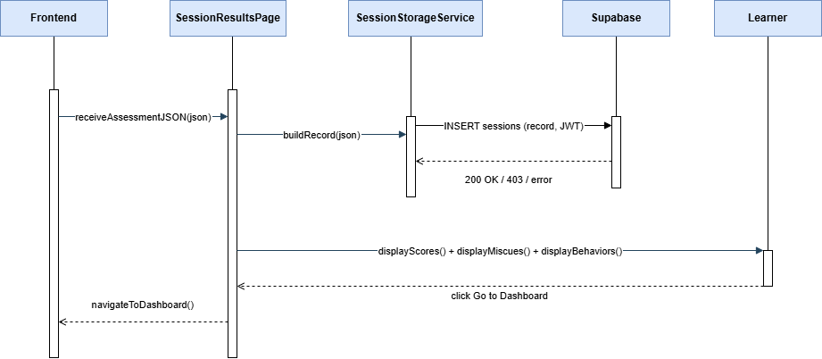

Data Design
No new persistent data written by this specific rendering transaction. The SessionResultsPage reads from the in-memory AssessmentResultJSON only. The database write is the responsibility of UC-4.2.

4.2 Session Record Storage

Front-End Component
Property | Value
Component Name | SessionStorageService
Description and Purpose | Triggered immediately after the AssessmentResultJSON is received, concurrent with SessionResultsPage rendering. Constructs a complete SessionRecord object from the JSON, appending the learner's user ID (from the Supabase JWT), session timestamp, and passage_id. Calls the Supabase PostgREST INSERT endpoint for the sessions table with the learner's JWT as a Bearer token. Retries up to 3 times with exponential backoff on failure. If all retries fail, renders a save-failure warning banner on the SessionResultsPage without losing the in-session results.
Component Type / Format | React custom hook (useSessionStorage) — called from SessionResultsPage on mount. Uses @supabase/supabase-js client. Returns { saveStatus: success | failed, error: string | null }.

Back-End Component
Property | Value
Component Name | Supabase PostgREST + RLS (sessions table)
Description and Purpose | Receives the INSERT request from the frontend with the learner's JWT as a Bearer token. Supabase Row-Level Security validates that the learner_id field in the record matches the sub claim of the JWT, rejecting mismatches with HTTP 403. On validation success, persists the record to the PostgreSQL sessions table. Returns 201 Created on success.
Component Type / Format | Supabase managed PostgreSQL + PostgREST auto-generated REST API. RLS policy: INSERT allowed only when auth.uid() = learner_id. No custom server-side code required.

Sequence Diagram
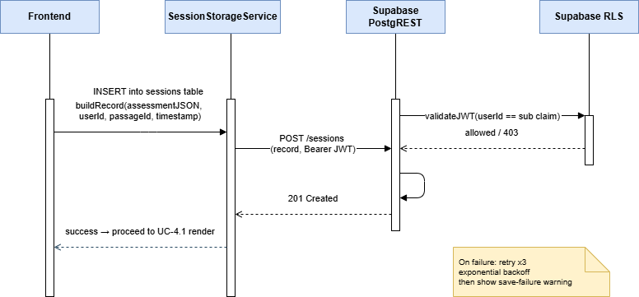

Data Design
This is the primary persistent table for the ReadRight system. All 19 columns below are written by this transaction and subsequently read by the Personal Progress Dashboard (UC-4.3 and UC-4.4).
Field | Type | Constraints | Description
session_id | UUID | PRIMARY KEY, DEFAULT gen_random_uuid() | Unique identifier for each session record.
learner_id | UUID | NOT NULL, FK → auth.users(id) | Supabase Auth user ID of the learner. Referenced by RLS policy.
passage_id | VARCHAR(50) | NOT NULL | Identifier of the Phil-IRI passage randomly assigned for this session.
session_timestamp | TIMESTAMPTZ | NOT NULL, DEFAULT now() | UTC timestamp when the session record was created.
wpm | FLOAT | NOT NULL | Words per minute computed by ScoringEngine (UC-2.3).
word_recognition_pct | FLOAT | NOT NULL | Word recognition percentage computed by ScoringEngine (UC-2.3).
reading_level | VARCHAR(20) | NOT NULL | Phil-IRI reading level classification: Frustration | Instructional | Independent.
correct | INTEGER | NOT NULL, DEFAULT 0 | Count of correctly read words (UC-2.2).
mispronunciation | INTEGER | NOT NULL, DEFAULT 0 | Count of mispronunciation miscues (UC-2.2).
substitution | INTEGER | NOT NULL, DEFAULT 0 | Count of substitution miscues (UC-2.2).
omission | INTEGER | NOT NULL, DEFAULT 0 | Count of omission miscues (UC-2.2).
insertion | INTEGER | NOT NULL, DEFAULT 0 | Count of insertion miscues (UC-2.2).
repetition | INTEGER | NOT NULL, DEFAULT 0 | Count of repetition miscues (UC-2.2).
refusal_to_pronounce | INTEGER | NOT NULL, DEFAULT 0 | Count of refusal-to-pronounce miscues (UC-2.2).
finger_pointing | BOOLEAN | NOT NULL, DEFAULT FALSE | True if finger-pointing detected by CVDetector (UC-3.1).
loss_of_place | BOOLEAN | NOT NULL, DEFAULT FALSE | True if loss-of-place eye movement detected by CVDetector (UC-3.1).
monotone_reading | BOOLEAN | NOT NULL, DEFAULT FALSE | True if monotone reading detected by ProsodyAmplitudeDetector (UC-3.2).
word_by_word_reading | BOOLEAN | NOT NULL, DEFAULT FALSE | True if word-by-word reading detected by ProsodyAmplitudeDetector (UC-3.2).
inaudible_reading | BOOLEAN | NOT NULL, DEFAULT FALSE | True if inaudible reading detected by ProsodyAmplitudeDetector (UC-3.2).

Indexes: CREATE INDEX ON sessions (learner_id, session_timestamp) — required per NFR-P3 for dashboard query performance.

4.3 Reading Level Trend and WPM Progression Charts

Front-End Component
Property | Value
Component Name | PersonalProgressDashboard — Trend Charts
Description and Purpose | On mount, issues a single SELECT query to Supabase for all session records belonging to the authenticated learner ordered by session_timestamp ascending. Renders two charts from the fetched data: (1) Reading Level Trend chart — a line or step chart mapping Phil-IRI level classifications to numeric values (Frustration = 1, Instructional = 2, Independent = 3) across sessions, with session date on the x-axis. (2) WPM Progression chart — a line chart plotting wpm values per session with Phil-IRI Grade 4 WPM benchmark reference lines. Displays an empty state message if no sessions exist.
Component Type / Format | React page component (PersonalProgressDashboard). Chart rendering using a charting library (e.g., Recharts or Chart.js). Session data fetched via useSessionHistory custom hook using @supabase/supabase-js. The fetched dataset is shared with UC-4.4 — no duplicate query is issued.

Back-End Component
Property | Value
Component Name | Supabase PostgREST + RLS (sessions table SELECT)
Description and Purpose | Receives the SELECT query from the frontend with the learner's JWT. RLS validates the JWT and returns only session records where learner_id = auth.uid(). Results are ordered by session_timestamp ascending for chronological chart rendering. The query uses the composite index on (learner_id, session_timestamp) to meet the 5-second dashboard load time NFR.
Component Type / Format | Supabase managed PostgreSQL + PostgREST. RLS policy: SELECT allowed only for rows where auth.uid() = learner_id. No custom server-side code required.

Sequence Diagram
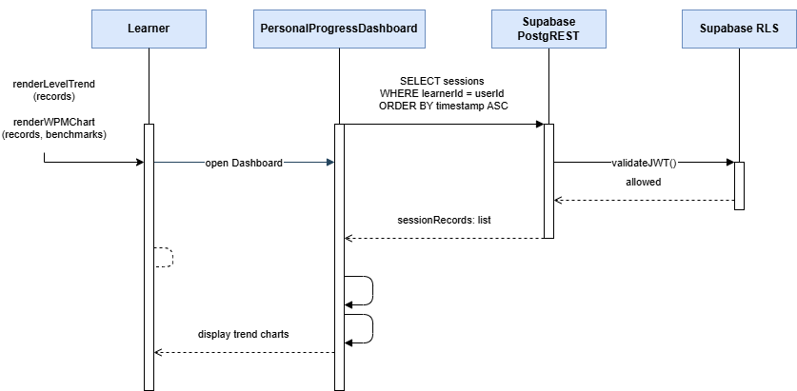

Data Design
Reads from the sessions table (defined in UC-4.2). Columns consumed: session_id, session_timestamp, reading_level, wpm. No new data is written by this transaction.

4.4 Miscue Breakdown and Behavioral History Display

Front-End Component
Property | Value
Component Name | PersonalProgressDashboard — Miscue and Behavioral Panels
Description and Purpose | Reuses the session records already fetched by UC-4.3 (no additional database query). Renders two additional dashboard sections: (1) Miscue Breakdown chart — aggregates miscue counts across all sessions by category and renders a bar or pie chart showing the distribution of mispronunciation, substitution, omission, insertion, repetition, and refusal to pronounce across the learner's full session history. (2) Behavioral History section — displays each of the five Phil-IRI qualitative behaviors as a row, with a visual indicator showing how frequently each behavior was flagged across all sessions (e.g., flagged count or session-by-session checklist icons).
Component Type / Format | Rendered as additional sections within the PersonalProgressDashboard React component. Uses session data from the useSessionHistory hook shared with UC-4.3. No additional API call.

Back-End Component
No additional back-end component. This transaction reuses the session data fetched in UC-4.3. Supabase is not queried again.

Sequence Diagram

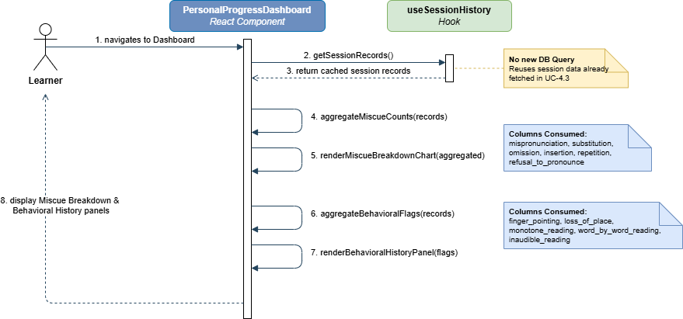

Data Design
Reads from the sessions table (defined in UC-4.2). Columns consumed: correct, mispronunciation, substitution, omission, insertion, repetition, refusal_to_pronounce (for Miscue Breakdown); finger_pointing, loss_of_place, monotone_reading, word_by_word_reading, inaudible_reading (for Behavioral History). No new data is written by this transaction.

